ADAPTIVE MODULATION IN OPTICAL FIBER COMMUNICATION

|  |  |  |  |
| --- | --- | --- | --- |
| Dr.Rohan prasad Department of EECE Gitam University Bengaluru,India rprasad@gitam.edu | G Hemanth Department of EECE Gitam University Bengaluru,India hgolla2@gitam.in | B M KGanesh Department of EECE Gitam University Bengaluru,India mganesh@gitam.in | J Surya Teja Department of EECE Gitam University Bengaluru,India sjanardhgitam.in |

*Abstract*— Computer communication through data at high speed relies heavily on fiber optics to provide efficient transmission capabilities. Transmission of signals with high bit rates over long distances faces three main obstacles which include signal attenuation together with chromatic dispersion and non-linear effects. The research studies QPSK modulation for fiber optic communication through a 50 km transmission distance at a 40 GHz data rate. The research utilizes OptiSystems simulation software to study Bit Error Rate (BER) and Signal-to-Noise Ratio (SNR) and various dispersion compensation methods. The experimental results prove QPSK provides a good combination between spectral efficiency and transmission reliability which makes it superior to traditional modulation techniques such as BPSK for high-speed optical systems. The results generate new advancements in optical communication technologies which can find applications in telecommunications structures alongside high-speed data centers. The field needs further study to incorporate sophisticated error correction systems together with machine learning techniques for maximizing system performance.

Keywords— QPSK, SNR, BER

Introduction

The modern digital environment has witnessed increased demand for fast dependable data transmission which resulted from technological advancements in cloud computing as well as video streaming and artificial intelligence and the Internet of Things (IoT). High-speed network operations depend on optical fiber communication because it provides better system capabilities compared to conventional transmission networks that use copper cables. The high-speed capabilities of optical fiber transmission compete with additional benefits which include high bandwidth capabilities as well as low signal reduction while providing protection from electromagnetic interference and better security measures. A collection of technical difficulties continues to affect high-speed and long-distance communication even after its numerous beneficial outcomes.

Fiber optic network reliability suffers from signal degradation which arises due to chromatic dispersion together with attenuation and nonlinear effects. The increasing date rates make these problems more severe which requires innovative modulation methods to maintain signal quality. The field of adaptive modulation now receives considerable interest because it efficiently controls data transmission through channel-dependent modulation scheme adjustments. QPSK proves as an efficient modulation technique for optical fiber systems because it uses two-bits-per-symbol encoding that raises spectral efficiency while reducing bandwidth usage.

The project develops and simulates a 40 GHz QPSK-based optical fiber communication system which operates through a 50 km fiber optic link. The research executes its analysis within OptiSystems which specializes in optical communication system modeling and analysis. Simulation helps the project measure three essential performance metrics including Bit Error Rate (BER) along with Signal-to-Noise Ratio (SNR) and eye diagrams to determine QPSK modulation effectiveness. Researchers explore different compensation methods to reduce the effects of both dispersion and attenuation alongside performing an analysis of these phenomena.

High-speed optical communication network development benefits from this research study. This research produces knowledge that allows applications in telecommunications and data centers as well as future networking solutions. The study establishes groundwork for future innovations because it proposes three main improvements: Forward Error Correction (FEC) integration along with advanced dispersion compensation methods and machine learning-based signal processing to boost system performance.

The research makes an essential contribution to the development of fast optical communication network systems. The research findings provide knowledge that serves telecommunications systems together with data centers and emerging networking solutions. The study introduces essential building blocks for new advancements because it describes how future improvements should incorporate Forward Error Correction (FEC) schemes with advanced dispersion compensation techniques and machine learning-based signal processing to achieve better system performance. Optimizing fiber optic communication represents a vital requirement for preserving digital service expansion because data requirements keep escalating worldwide. This research study brings insightful information to assist both the industry experts and academic researchers focusing on developing more efficient and economical optical networking systems. The study adds valuable progress to high-speed data transmission evolution through its analysis of QPSK implementation. The obtained results provide guidelines for developing improved modulation techniques set to improve both the performance and dependability of optical fiber communication systems.

# Methodology

The project implements a systemized method which encompasses QPSK-based optical fiber communication system design and simulation and evaluation. Several key stages comprise the process starting with preliminary research moving to system design then setup of simulation followed by testing leads to performance analysis. The research utilizes OptiSystems along with MATLAB as tools to create and analyze the QPSK-based optical fiber communication system.

## Research and Problem Definition

The starting point for this project requires researching core concepts of optical fiber communication combined with different speed data transmission limitations. Modern communication networks select optical fibers because they combine high bandwidth along with minimal signal loss while offering defense against electromagnetic disturbances. Increasing data rates create obstacles for signal quality because chromatic dispersion, attenuation, nonlinear distortions, and noise become major issues.

Multiple studies investigate modulation techniques for various applications where Binary Phase Shift Keying (BPSK) joins Quadrature Amplitude Modulation (QAM) and Quadrature Phase Shift Keying (QPSK) among them. QPSK proves optimal because it executes two-bit symbol encoding which provides superior spectral efficiency along with signal resistance to deterioration. The research investigates dispersion compensation methods because these strategies are vital for enhancing signal transmission abilities during extensive deliveries.

## System Design and Parameter Selection

The system functions at 40 GHz bit rate while using 50 km single-mode fiber (SMF) links. The selection of SMF as fiber type happened because it provides reduced dispersion that supports high-speed signal maintenance. The CW laser function as optical carrier operates at 1550 nm wavelength because this minimizes signal loss yet stays common among fiber optic communication systems.

Fiber optic link parameters receive precise definitions because they need to reflect actual transmission scenarios. The system implements an attenuation coefficient of 0.2 dB/km because it demonstrates signal power degradation across fiber distance. System performance requires mitigation of chromatic dispersion since its value is set to 16 ps/nm/km. The set parameters accurately model the QPSK system to facilitate performance assessment in real-life situations.

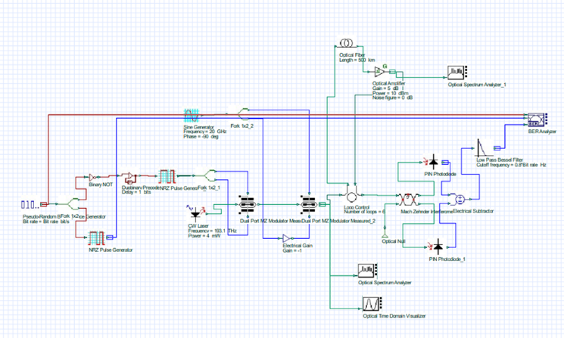

## Simulation Setup

The proposed system validation process relies on OptiSystems to perform a detailed simulation of optical communication network analysis. The simulation system contains three essential parts which are:

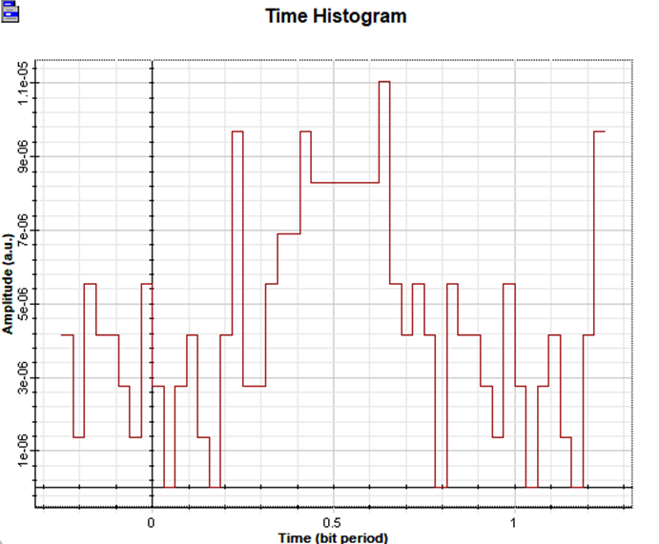

**Transmitter Design**: The transmitter function converts digital input data into optical signals through its design. It consists of:

* The Pseudorandom Binary Sequence generator produces transmission-ready random bit sequences for delivery.
* The transmitter includes a QPSK modulator implementing bit-to-phase transition for signal encoding.
* The transmitter depends on a CW laser running at 1550 nm for producing a stable carrier signal to transmit signals.
* The transmission medium for Optical Fiber Channel functions through a fiber optic link that includes realistic impairments.

**Optical Fiber Channel:** The fiber optic link serves as the transmission medium, incorporating realistic impairments:

* About 50 km of Single-mode fiber (SMF) provides minimum modal dispersion because of its unique design.
* The transmission of signals experiences degradation from two effects including signal weakness and wavelength-dependent signal spreading.
* The receiver instrument provides optical signal processing through digital data transmission.

**Receiver Design:** The receiver converts the transmitted optical signal back into digital data:

* A QPSK demodulator serves the purpose of decoding the received phase-shifted signal.
* An optical signal gets transformed into electrical form by using a photodetector device.
* A low-pass filter enables signal clarification by eliminating high-frequency noise.

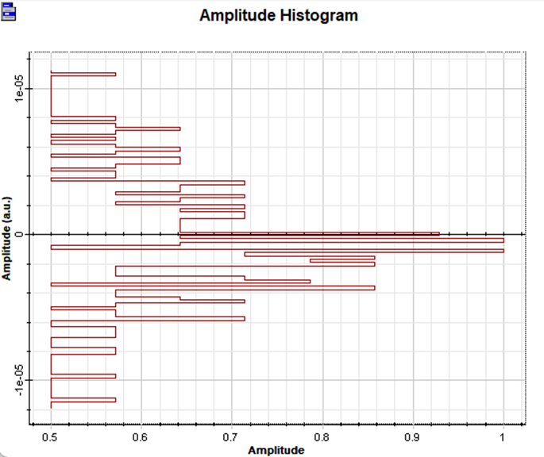

# Result

## Performance Evaluation:

The performance analysis of the system takes place after design and implementation through multiple important metrics. Performance indicators which hold the most significance consist of:

* The Bit Error Rate (BER) evaluation technique determines the relationship between received erroneous bits versus total transmitted bits. Better transmission reliability can be achieved through decreased BER results.
* The Signal-to-Noise Ratio measurement provides evaluations about received signal power relative to background noise to maintain data reliability.
* The graphical depiction known as eye diagrams enables viewing the signal's clarity state. A device with a clear eye pattern shows good signal quality while visualizing closed eyes indicates the signals are undergoing signal degradation.
* The signal space accuracy of symbol placement emerges from Constellation Diagram analysis that detects multiple transmission impurities including phase noise and jitter and distortion.

The built-in analysis tools in OptiSystems generate these testing results to provide an accurate performance evaluation for QPSK systems during different transmission scenarios.

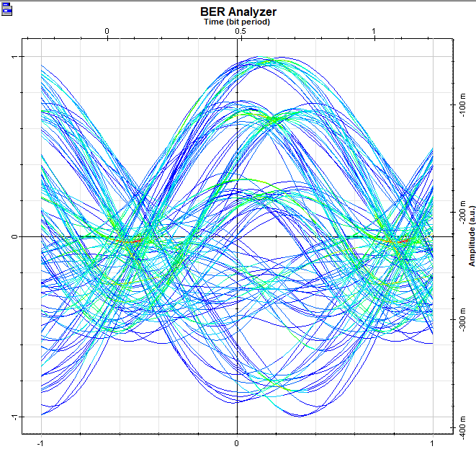

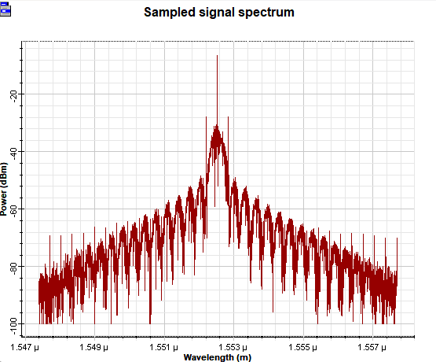

## Comparative Analysis

A performance assessment of QPSK modulation depends on its comparison against BPSK and QAM modulation. BPSK demonstrates superior signal protection against noise but provides lower spectral efficiency whereas QAM provides faster transmission speed but shows reduced resistance to environmental noise and distortions. QPSK achieves its viability for optical transmission at high speeds by showing its advantages compared to alternative modulation techniques.

This research evaluates pre-compensation and post-compensation techniques as dispersion compensation methods for their effectiveness in minimizing chromatic dispersion effects. These methods achieve better BER and SNR metrics which proves their efficacy for sustaining signal quality across distant fiber links.

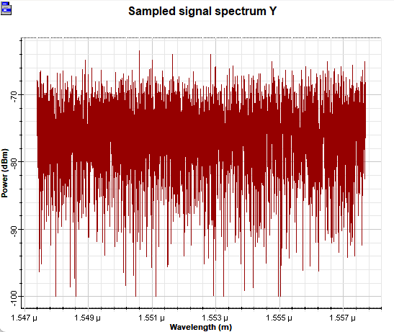

## Optimization and Future Enhancements

The concluding stage of the research project involves conducting enhancements to the QPSK system to achieve superior operational results. The QPSK system can benefit from Forward Error Correction methods especially Reed-Solomon coding and Low-Density Parity-Check coding because these techniques enhance error resilience while improving system reliability. The implementation of adaptive filtering combines DSP to adjust filter parameters automatically based on changing transmission conditions to achieve optimal results.

Higher-order modulation techniques such as 16-QAM and 64-QAM serve as potential methods to increase data rates which leads to better throughput levels. The application of machine learning techniques for signal processing optimization through AI-driven methodology enables real-time adjustments which decreases errors and enhances system operational efficiency.

##### Conclusion

The team succeeded in designing and simulating QPSK modulation for optical fiber communication to enable fast data transfers across a 50 km fiber link. The analysis of QPSK system performance included testing with BER measures along with SNR evaluation and the inspection of both eye diagrams and constellation diagrams. The experimental results showed that QPSK modulation strikes an optimum point between spectrum utilization and signal integrity and should be used for fast and long-range laser data transmissions.

The research investigated possible upcoming system improvement methods which include Forward Error Correction (FEC) and adaptive filtering together with machine learning-based optimization techniques. The enhancements would increase the system capability to support rapid data transfer in modern optical transmission networks.

The experimental model incorporated correct dispersion compensation methods which successfully managed chromatic dispersion together with signal attenuation and nonlinear effects. It became evident through performance comparisons that QPSK exceeded BPSK and QAM in terms of reliability as well as operating efficiency.

The presented research helps advance optical fiber communication systems by providing essential knowledge for developing effective high-capacity optical transmission networks. The framework created now serves as a base for upcoming research and technological advancements in optical communication systems that lead to quicker dependable networks.

##### References

1. Chowdhury, M.A.N., Mahfuz, M.U., Chowdhury, S.H., Kabir, M.M.: Design of an improved QPSK modulation technique in wireless communication systems. In: IEEE International Conference on Electrical Information and Communication Technology (EICT) (2017)

[2] Pareek, V.: A novel implementation of QPSK modulator on FPGA. In: IEEE Students’ Conference on Electrical, Electronics and Computer Science (SCEECS) (2016)

[3] Birla, N., Gautam, N., Patel, J., Balaji, P.: A novel QPSK modulator. In: IEEE International Conference on Advanced Communications, Control and Computing Technologies (2014)

[4] Jain, M., Kesharwani, P., Malviya, A.K., Khare, K., Shandilya, P., Haldar, S., Rai, H., Aggarwal, S.: Performance optimized digital QPSK modulator. In: International Conference on Energy, Communication, Data Analytics and Soft Computing (ICECDS) (2017)

[5] Gunther J. and Moon T. (2009) Burst Mode Synchronization of QPSK on AWGN Channels using Kurtosis of IEEE, 57, 2453- 2462.

[6] T. Ruhlicke, M. Zannoth, and B. U. Klepser, “A highly integrated, dualband, multi-mode wireless lan transceiver,” Proceedings of ESSCIRC’03, pp. 229–232, 2003.

[7] K. A. Monpara and S. B. Parmar, “Design and implementation of qpsk modulator using digital sub-carrier,” Journal of Information, Knowledge and Research in Electronics and Communication Engineering, vol. 2, no. 2, pp. 569–573, 2012.

[8] T. Sakla, D. Jain, and S. Gautam, “Implementation of digital qpsk modulator by using vhdl/matlab,” International Journal of Engineering Service and Technology, vol. 2, no. 9, pp. 4827–4831, 2010.